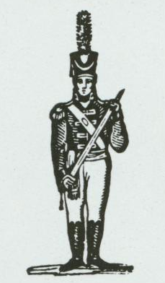  Svalbard | Peru | Mongolia | Kamchatka
Middle East | Siam | Venezuela | East Africa
Iceland | Egypt | Oikiqtaluk | Argentina
Congo | China | Alaska | New Guinea
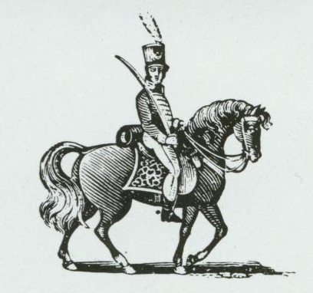  Yakutsk | India | Ural | Ukraine
Quebec | Scandinavia | Ontario | Irkutsk
Siberia | Madagascar | Afghanistan | Greenland
Falkland Islands | Alberta | North Africa | Hawaii
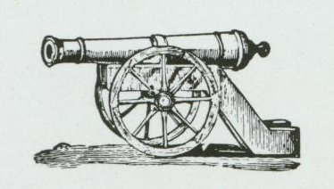  Central America | Philippines | Northern Europe | Western Australia
Western United States | New Zealand | Southern Europe | Northwest Territory
Eastern United States | Brazil | Western Europe | South Africa
Eastern Australia | Great Britain | Indonesia | Japan
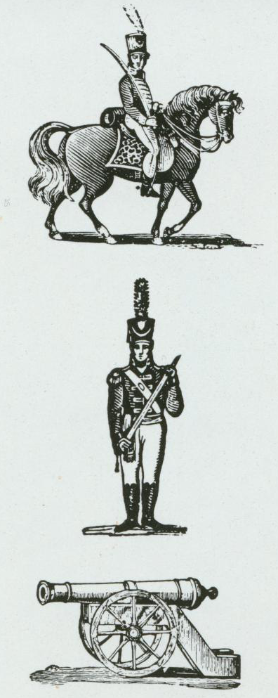  Wild | Wild | These Risk II cards must be used instead of those that come with a standard Risk game. The correlation between territories and infantry/cavalry/cannon is different from a standard deck in most cases. Six new territories have also been added to the board and are therefore represented in this deck. | Hi, mom!

